 | VICTORIA JUNIOR COLLEGE  JC 2 PRELIMINARY EXAMINATIONS  Higher 2
CHEMISTRY |  |  | 9647/03
Paper 3 Free Response  Candidates answer on separate paper. |  |  |  | 14 September 2010  2 hours
Additional Materials: |  | Answer Paper  Data Booklet

READ THESE INSTRUCTIONS FIRST

Write your name and CT group on all the work you hand in.
Write in dark blue or black pen on both sides of the paper.
You may use a soft pencil for any diagrams, graphs or rough working.
Do not use staples, paper clips, highlighters, glue or correction fluid.

Answer any four questions.
A Data Booklet is provided.
You are reminded of the need for good English and clear explanation in your answers.

The number of marks is given in brackets [ ] at the end of each question or part question.

This document consists of 10 printed pages.
1 Compounds of iron, cobalt and lead show variable oxidation states and undergo redox reactions readily.

(a)(i) By means of a fully labelled diagram, describe how the standard electrode potential of the Fe³⁺/Fe²⁺ system can be measured. Indicate the direction of electron flow.

(ii) Describe and explain what happens when Ag⁺(aq) is added to a solution containing Fe²⁺(aq) using relevant data from the Data Booklet. Give the expected observations and write equation(s) where appropriate.

When aqueous iron(II) sulfate is boiled with an excess of sodium cyanide a yellow solution of Na₄Fe(CN)₆ can be obtained. When chlorine gas is passed into the yellow solution, a red solution is formed.

(iii) Draw the shape of the complex ion in the yellow solution and state the coordination number of iron in the complex ion.

(iv) Use the Data Booklet to construct a balanced equation for the colour change observed from yellow to red.
[9]

(b) The lead–acid accumulator is a storage battery because it can be recharged. It consists of a series of cells containing lead plate anodes, lead dioxide plate cathodes and an electrolyte of 6 mol dm^{–3} sulfuric acid.

When it is operating, the reactions that occur at the electrodes are
PbSO₄(s) + 2e– ⇌ Pb(s) + SO₄^{2–}(aq) Eº = –0.13 V
PbO₂(s) + 4H⁺(aq) + SO₄^{2–}(aq) + 2e– ⇌ PbSO₄(s) + 2H₂O(l) Eº = +1.47 V

(i) Write the overall equation for the reaction upon discharge and calculate the voltage delivered by the battery if it contains a series of 6 cells.

(ii) Why is the battery rechargeable?

(iii) Explain why the measurement of the electrolyte density can be used to indicate the extent of discharge of the cell.

(iv) The above rechargeable cell is placed in a metallic alloy battery casing, and due to defective protective inner lining of the casing, the acid reacts with metal, M, in the alloy. A significant amount of M²⁺ ions were released into the electrolyte.

Given Eº(M²⁺⏐M) = +0.25 V, state and explain the effect, if any, of the leakage of M²⁺ ions on

(I) the charging process,

(II) the discharging process.
[7]
(c) A hot solution of sodium tartrate reacts with hydrogen peroxide giving a very slow stream of carbon dioxide. When a few drops of an aqueous cobalt(II) salt are added, the colour turns pink. Soon the colour of the solution turns green and a vigorous effervescence of carbon dioxide takes place. When the reaction stops, the pink colour is restored.

- What is the role of the cobalt(II) salt in this reaction?

- Give three reasons to support your answer in (c)(i).
[4]

[Total: 20]

2(a) Methanol is made from the following gaseous reaction.
CO(g) + 2H₂(g) ⇌ CH₃OH(g)

A 1:2 mixture of CO and H₂ was pumped into a sealed reactor at 6 atm and 25 ºC. The reactor was then heated to 227 ºC and maintained at this temperature for some time. When equilibrium was reached, the partial pressure of CH₃OH was found to be 3.2 atm.

It may be assumed that no reaction takes place during the period when the reactor was heated from 25 ºC to 227 ºC.

(i) Calculate the initial partial pressure of CO at 227 ºC, before any reaction has taken place.

- Write an expression for K_{p} for the reaction.

(iii) Calculate the partial pressures of CO and H₂ present at equilibrium.

(iv) Hence, determine the value of K_{p} at 227 ºC, stating its units.
[6]

(b) To account for the difference between a real and an ideal gas, J. D. van der Waals proposed the following equation for a real gas.

(P + n²a / V²) (V – nb) = nRT

where a, b are constants for a particular gas while the other letters have their usual meaning.

The table below shows the values of a and b for some gases.

gas | a / Pa m⁶ mol^{–2} | b / m³ mol^{–1}
helium | 3.41 x 10^{–3} | 2.34 x 10^{–5}
carbon dioxide | 3.64 x 10^{–1} | 4.27 x 10^{–5}
ammonia | 4.23 x 10^{–1} | 3.73 x 10^{–5}

(i) The values of a and b account for the deviation from ideality for a real gas and are dependent on certain molecular properties of the gas. For each of the constants a and b, suggest a molecular property of the gas that will directly affect its value.

(ii) Hence, explain qualitatively the rationale for the modifications made by van der Waals to the ideal gas equation.

(iii) Give reasons, in terms of bonding, for the difference in the values of a of the three gases in the table above.
[6]
(c) When CO₂ is dissolved in the blood plasma, a series of equilibria is established.
I CO₂(aq) + H₂O(l) ⇌ H₂CO₃(aq)
II H₂CO₃(aq) ⇌ H⁺(aq) + HCO₃⁻(aq)

Equilibrium II has a K_{a} value of 7.90 × 10⁻⁷ mol dm⁻³ and is responsible for buffering the pH of the blood plasma at 7.4.

In the lungs, excess dissolved CO₂(aq) is exhaled as CO₂(g) according to the following equilibrium.
III CO₂(aq) ⇌ CO₂(g)

During heavy exercise, lactic acid is released into the blood and is buffered by the blood plasma. The buffering action of the blood plasma will eventually lead to an increased breathing rate.

(i) Define the term buffer.

(ii) Use the data above to determine the [HCO₃⁻(aq)]/[H₂CO₃(aq)] ratio in the blood plasma.

- Write an equation to show why a high [HCO₃⁻(aq)] in the body is necessary to remove lactic acid. Use RCO₂H to represent lactic acid.

- Hence, by considering the effect on equilibria I and III, explain why the process of removing lactic acid causes the breathing rate to increase.

(v) A student wishes to simulate the blood plasma buffer by mixing 25.0 cm³ of 0.20 mol dm⁻³ H₂CO₃ solution with 0.30 mol dm⁻³ NaOH solution. The neutralisation that takes place is represented by

NaOH + H₂CO₃ → NaHCO₃ + H₂O

Using your answer in (c)(ii), calculate the volume of NaOH that should be added.
[8]
[Total: 20]
3(a) Like alcohols and halogenoalkanes, amines can be converted into alkenes by elimination reaction known as Hoffmann elimination reaction. For example, hexylamine is converted into hex−1−ene as shown.
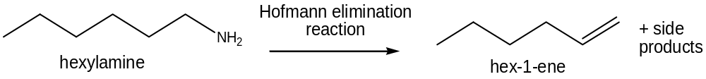

An organic salt A, C₇H₁₄NO₂, contains a singly charged cation and a singly charged anion. On acidification with dilute hydrochloric acid, A forms two compounds, B, C₂H₄O₂ and C, C₅H₁₄NCl. B reacts with LiAlH₄ in dry ether to give D, C₂H₆O, which gives a yellow precipitate with alkaline aqueous iodine. C reacts with aqueous sodium hydroxide to form an amine which undergoes Hoffmann elimination reaction to give only one alkene E, C₅H₁₀. E reacts with hot acidified KMnO₄ to give B and propanoic acid as the only organic products.

Deduce the structures for each lettered compound, A to E, and give an account of the chemistry involved.

Write balanced equations for the reactions of

- D with alkaline aqueous iodine,

(II) E with hot acidified KMnO₄.
[10]
(b) Like amines, quarternary ammonium ions can undergo Hoffmann elimination reaction in a single step mechanism as shown.
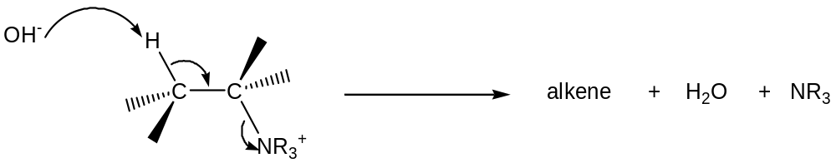

quarternary ammonium ion

(i) Write down the rate equation for this reaction and state the units of the rate constant. Use NR₄⁺ to represent the quarternary ammonium ion.

(ii) Sketch the graph of [OH–] against time to show that the reaction is first order with respect to OH–.

(iii) State how the half–life is changed (if any) when the experiment is repeated with the following changes.

(I) Concentration of OH– is doubled.

(II) Concentration of quarternary ammonium ion is doubled.
(iv) An increase of 10 ºC generally causes the reaction rate to be doubled. With the aid of a Boltzmann distribution curve, explain why a higher temperature increases the rate of a reaction.
[8]

(c) A quarternary ammonium ion undergoes elimination to give 2 possible products as shown.
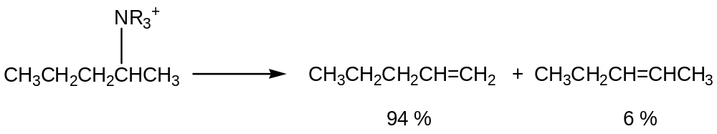

∆H > 0

The energy profile diagram of the above reaction is as shown.

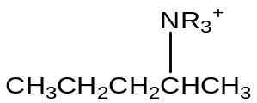
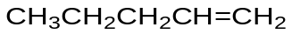
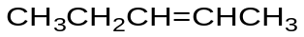
Reaction profile
Energy

Comment on the relative stabilities of the two alkenes and the relative activation energies. [2]

[Total: 20]

4 Halogens are essential reagents in the chemical industry leading to the formation of many important halogen–containing compounds.

(a)(i) A halogen, X₂, reacted completely with 0.0125 mol of S₂O₃^{2–}(aq). This resultant acidic solution was divided into two equal portions for the following reactions.

One portion was treated with an excess of aqueous silver nitrate to produce 0.0500 mol of silver halide. Another portion was treated with an excess of aqueous barium nitrate to produce 0.0125 mol of white precipitate which is insoluble in dilute nitric acid.

Construct a balanced equation for the reaction between X₂ and S₂O₃^{2–}(aq).

(ii) Another halogen, Y₂, gave a different sulfur–containing product with S₂O₃^{2–}(aq). Write the equation for the reaction.

(iii) Give a reason for the difference in the reactions in (a)(i) and (a)(ii).
[4]

(b) Chlorine dioxide, ClO₂, is a yellow gas which is commercially used to bleach flour for making white bread. As chlorine dioxide explodes above –40 ºC, it is often generated in situ by heating aqueous NaClO₃ with ethanedioic acid, H₂C₂O₄.

- State how aqueous NaClO₃ may be obtained from chlorine.

(ii) State the role of ethanedioic acid in its reaction with aqueous NaClO₃. Give a reason for your answer.
[2]

(c) A chlorine–containing compound W has the structure shown.

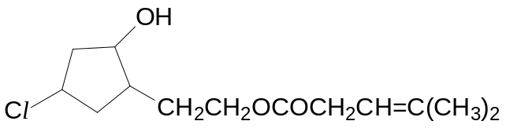

Give the structures of the organic products formed when W is heated with

(I) aqueous NaOH,

(II) acidified KMnO₄
[5]

(d) Anhydrous aluminium chloride acts as a catalyst in the reaction of benzene with chlorine.

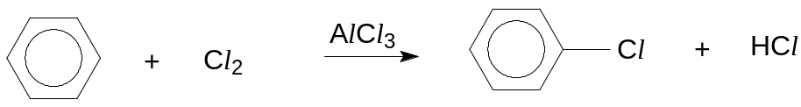

Ethanoyl chloride, CH₃COCl, also reacts similarly with benzene to produce carbonyl compounds. The process is called Friedel–Crafts acylation.

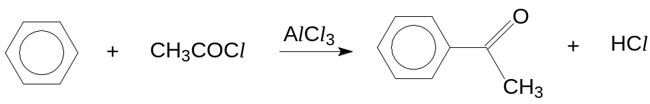

- Describe the mechanism of the above reaction between ethanoyl chloride and benzene.

- By making use of Friedel–Crafts acylation and suitable starting materials, suggest a synthetic pathway to convert benzene into the following compounds. State clearly the reagents and conditions for each stage, and draw the structural formula of every intermediate.

(I) 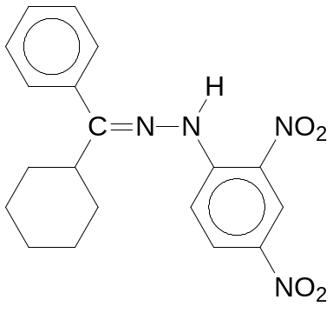

(II) 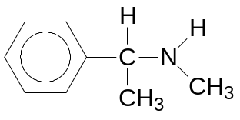
[Hint for (II): The first step involves the reaction between ethanoyl chloride and benzene.]
[9]

[Total: 20]

5(a) Phenylalanine, C₆H₅CH₂CH(NH₂)CO₂H, is an amino acid that can be found in the food we eat. It exists as a crystalline solid of zwitterions in the dry state. The isoelectric point of phenylalanine is pH 6.

- What do you understand by the terms isoelectric point and zwitterion?

- Give the displayed formula of phenylalanine at pH 6.

- Write balanced equations for the reaction of phenylalanine with HCl and with NaOH respectively.

- Phenylalanine has a high melting point and dissolves readily in polar solvents such as water. Explain these two physical properties in terms of structure and bonding.
[7]

(b) Proteins can be classified as fibrous or globular proteins. Fibrous proteins are generally insoluble in water while globular proteins dissolve readily in water. The structures of globular proteins are stabilised by interactions between R groups of the amino acid residues.

Explain the difference in solubility of fibrous and globular proteins in water in terms of their structures. [2]

(c) Enzymes are globular proteins which can catalyse biological reactions. Pepsin is a proteolytic enzyme which can catalyse the hydrolysis of polypeptides.

(i) Write a balanced equation to show the enzymic hydrolysis of a peptide bond.

(ii) Explain why boiled pepsin is unable to perform its catalytic role with reference to its chemical bonds and give the name of the process that has taken place.
[3]

(d)(i) Suggest how the following conversions (steps I to III) can be carried out. State the type of reaction, the reagents and conditions for each step.

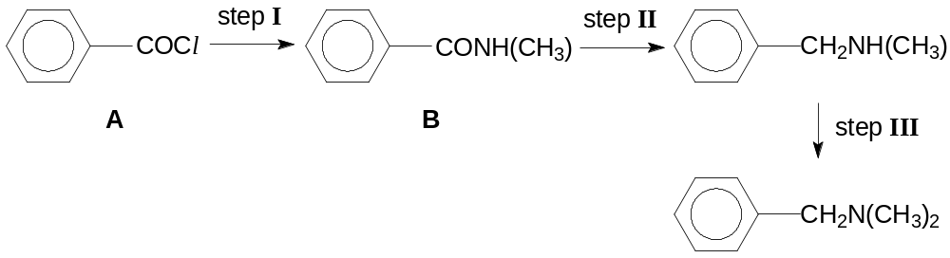
(ii) Describe a chemical test, giving the reagents, conditions and observations which would allow you to distinguish compound A from compound B.
[8]

[Total: 20]

